Book Club in a Bag – KS1
Superheroes

Book | Introduction | Key questions
Session 1
Knock Knock Superhero by Caryl Hart. Illustrated by Nick East  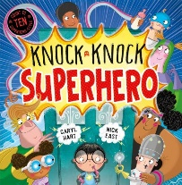 | Knock, knock! There's a superhero at the door! Pasta Man has run out of Pasta Power. . . Can our young hero help him to get his powers back and defeat evil Madame Chilli, who wants to rule the world with lashings of chilli sauce? | - Would you like a superhero to knock on your door?  - Would you like to be a superhero? What powers would you have?  - Do you think Pasta man is a good name for a superhero?  - Would you like a secret lair under your house?  - What gadgets would you include on a super car?  - Can you remember how many of each superhero there were?  - Which words rhymed in the story?  - Which illustration was your favourite?
Session 2
A Hero Called Wolf by Lucy Rowland. Illustrated by Ben Mantle  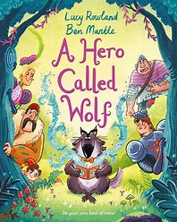 | Wolf is fed up. He loves reading about heroes, but none of them are ever like him. They’re handsome, tough and strong- and they’re definitely not wolves! But when a scary giant comes stomping up to the library, can Wolf save the day? Because perhaps real heroes just need just need to be kind and brave… | - Which stories have you read before with a wolf in? What was the wolf like?  - Do you think a wolf can be the star of a book?  - How was Wolf able to help each character in the story?  - Which book would you recommend to a giant?  - Do you think you could be a hero? Do you have the same qualities as Wolf- clever, kind and brave?  - If you were going to write a story about you, what type of character would you be?
Session 3
A Superhero Like You by Dr Ranj. Illustrated by Liam Darcy  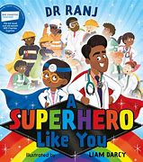 | Lily knows exactly what she wants to be when she grows up: A superhero! From doctors to teachers, recycling-truck drivers to carers – join Lily as she discovers the amazing work these real-life superheroes do. | - Do you think real people can be superheroes?  - Do you think you can be a superhero?  - What powers do you think Supersock has?  - Which other skills do you think doctors have that make them super?  - How many different animals can you see at the vets?  - Do you think guinea pigs are grumpy?  - Can you think of adjectives to describe the different animals and how they behave?  - Which of these jobs would you like to do and why?  - Which skills do you think you have that could make you a real hero?

Session 4
Zippo the Super Hippo by Kes Gray. Illustrated by Nikki Dyson  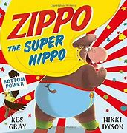 | Meet the superhero with the super bottom.  Zippo the Hippo longs to be super. There’s just one problem – hippos don’t have super powers. But Zippo does have a super-big bottom. Maybe there’s a power in that… | - What superpowers do you think a hippo might have?  - Do you think plodding, getting muddy and swimming are superpowers?  - How successful do you think Hippo’s flying lessons will be?  - How do you think the other animals are feeling about Hippo falling on them?  - How can Hippo help others as Super Hippobottomus?  - Which superpowers do you think other animals might have?
Session 5
Superbat by Matt Carr.  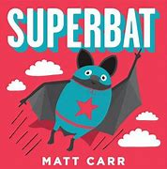 | Is it a bird?  Is it a plane? No…  It’s a bat in a funny costume.  Introducing SUPERBAT, an unlikely but mighty hero, ready to take the world by storm… in a cape made all by himself. | - What do you know about bats? Do they have any special skills?  - Do you read any comics?  - If you were making an outfit, what would it look like?  - Do you have to have different powers from others to be a superhero?  - Do you think Pat the Bat is special?  - Did any of the bat facts surprise you?
Session 6
All five books | Look at all 5 books again, reread any particular favourites. Can the children recall key events from the books.  - Which book was your favourite and why?  - Which character did you like the best and why?  - What have you learnt about superheroes?  - Do you have any superhero powers?  - Can you come up with a superhero name?  - Have you any ideas for your own superhero story?

